Courtney Burroughs, Johanna Teegarden, Makayla Cizek

**Dimensions Reasoning**

We did our best calculating reasonable dimensions using the provided data sheet. Some assumptions were made and can be seen below. The distances between the sensor and the LEDs were used to define the z-distance of the modeled cuboid.

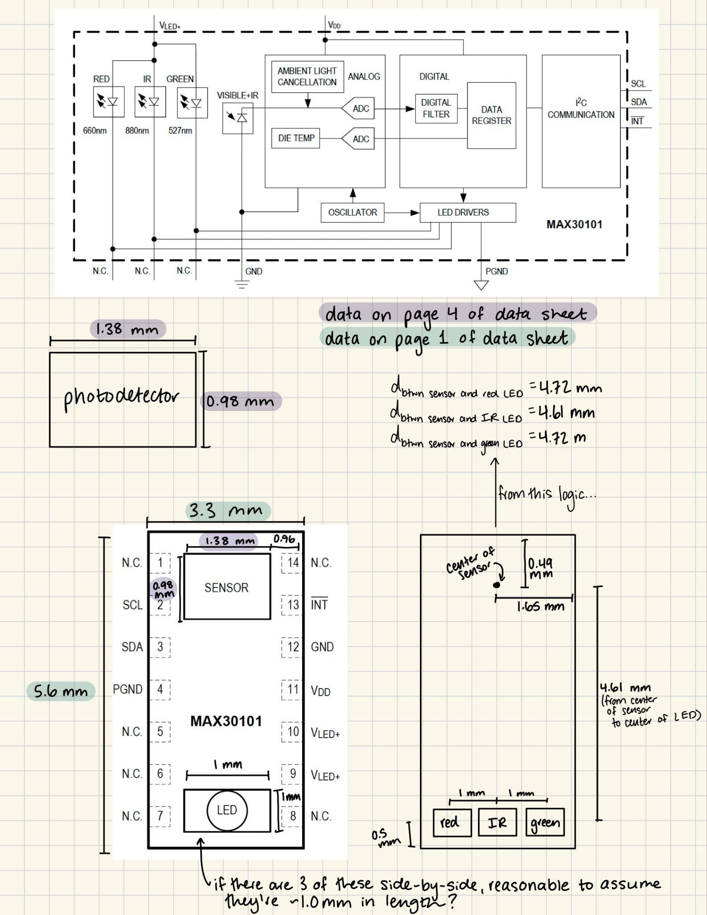

**Red LED Simulation**

* Power: 9.8 mW
* Wavelength: 660 nm
* MC Simulation Parameters
  + Distance between sensor and LED = 4.72 mm = 0.472 cm
  + # of photons simulated =7.41x105 photons
  + Simulation duration = 0.1 minutes
  + Photon simulation rate = 7.40x106 photons per minute
* MC Simulation Results
  + 30.5% of incident light was absorbed within the cuboid
  + 69.5% of incident light hits the cuboid boundaries.
* Model geometry

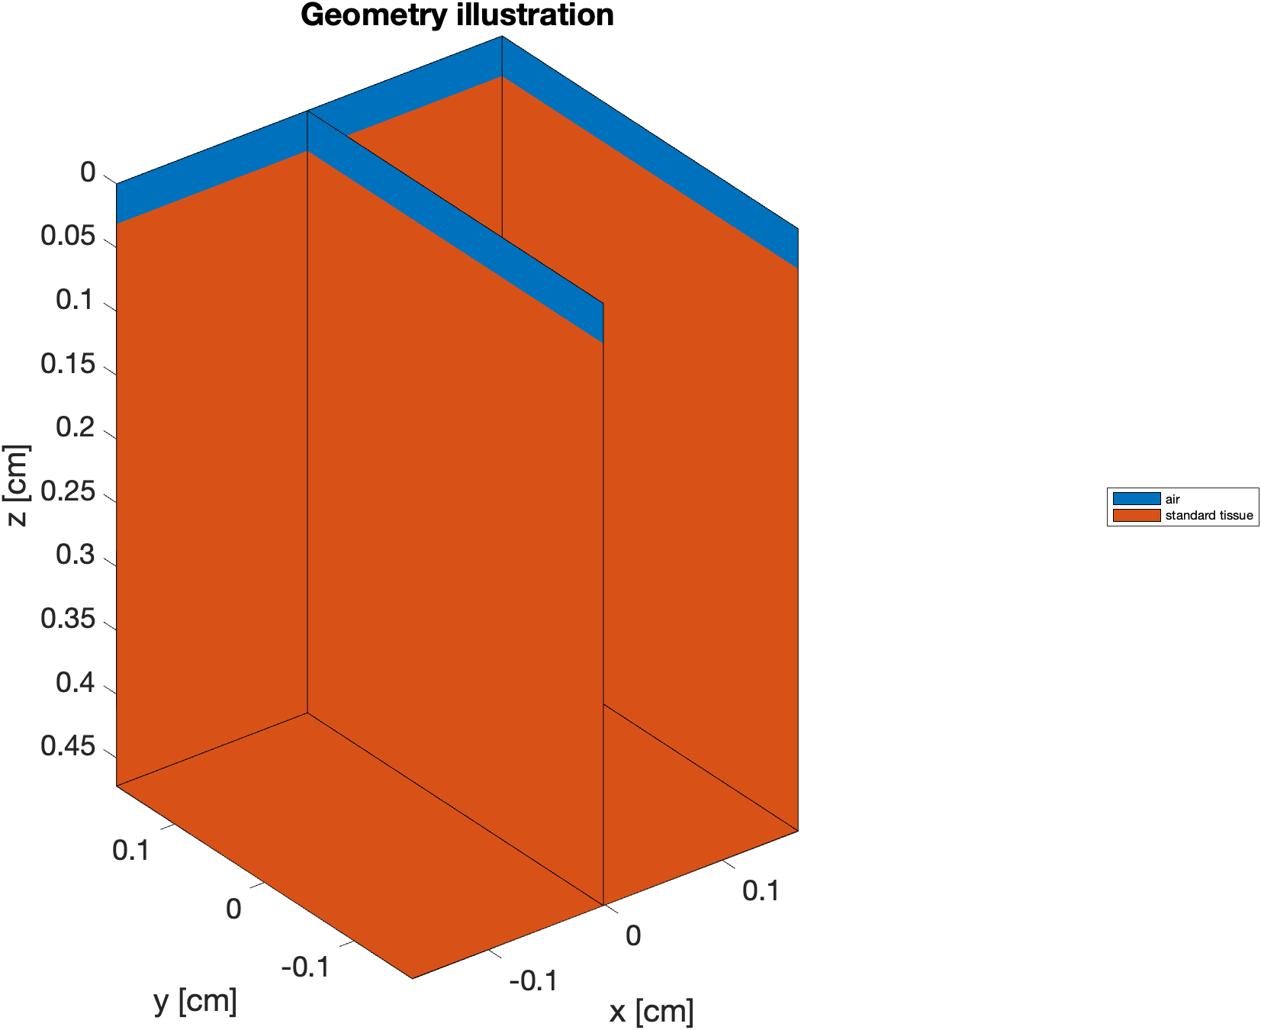

* Reflectance fluence

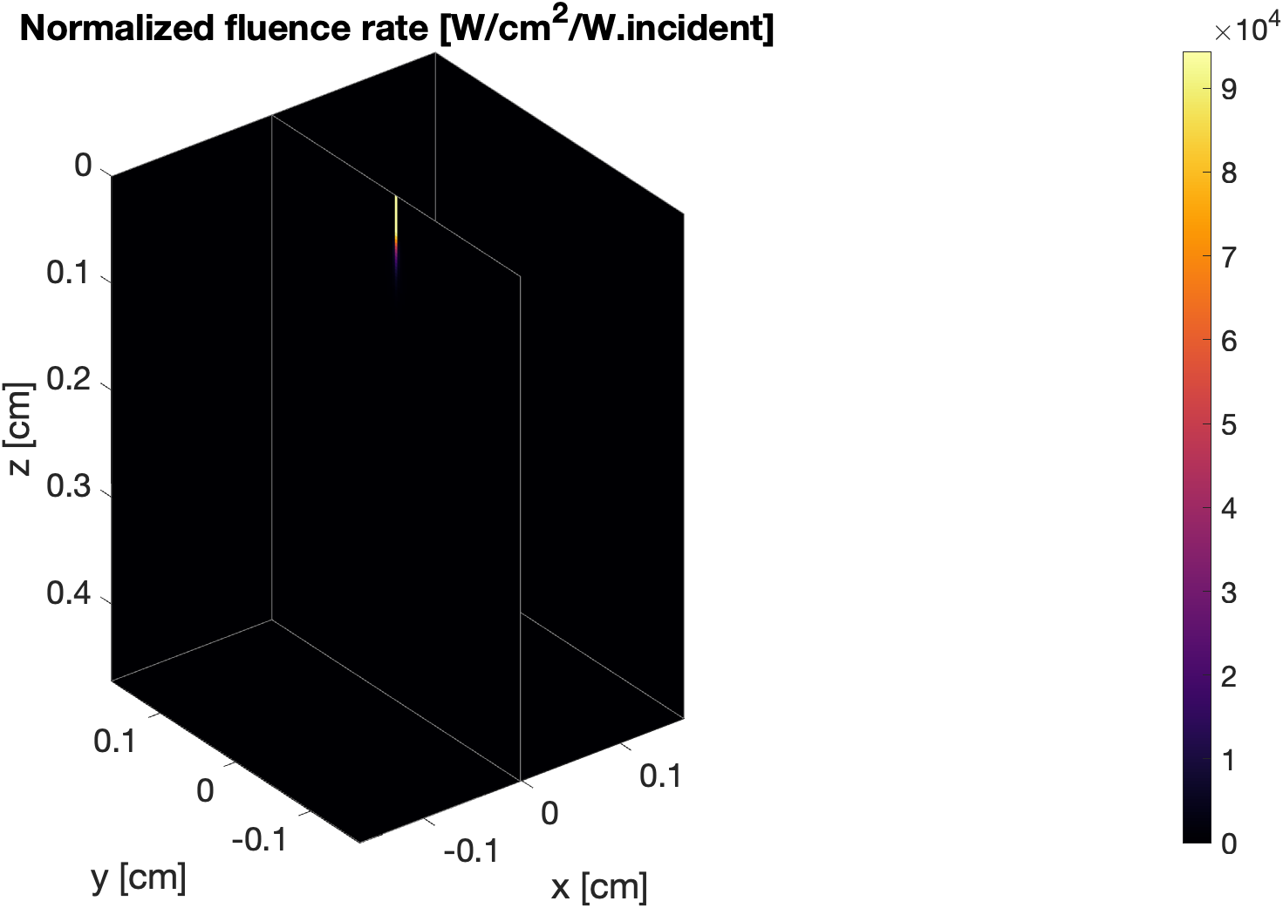

**IR LED Simulation**

* Power: 6.5 mW
* Wavelength: 880 nm
* MC Simulation Parameters
  + Distance between sensor and LED = 4.61 mm = 0.461 cm
  + # of photons simulated = Simulated 9.02x105photons
  + Simulation duration = 0.1 minutes
  + Photon simulation rate = 9.01x106photons/minute
* MC Simulation Results
  + 30.4% of incident light was absorbed within the cuboid
  + 69.6% of incident light hits the cuboid boundaries.
* Model geometry



* Reflectance fluence

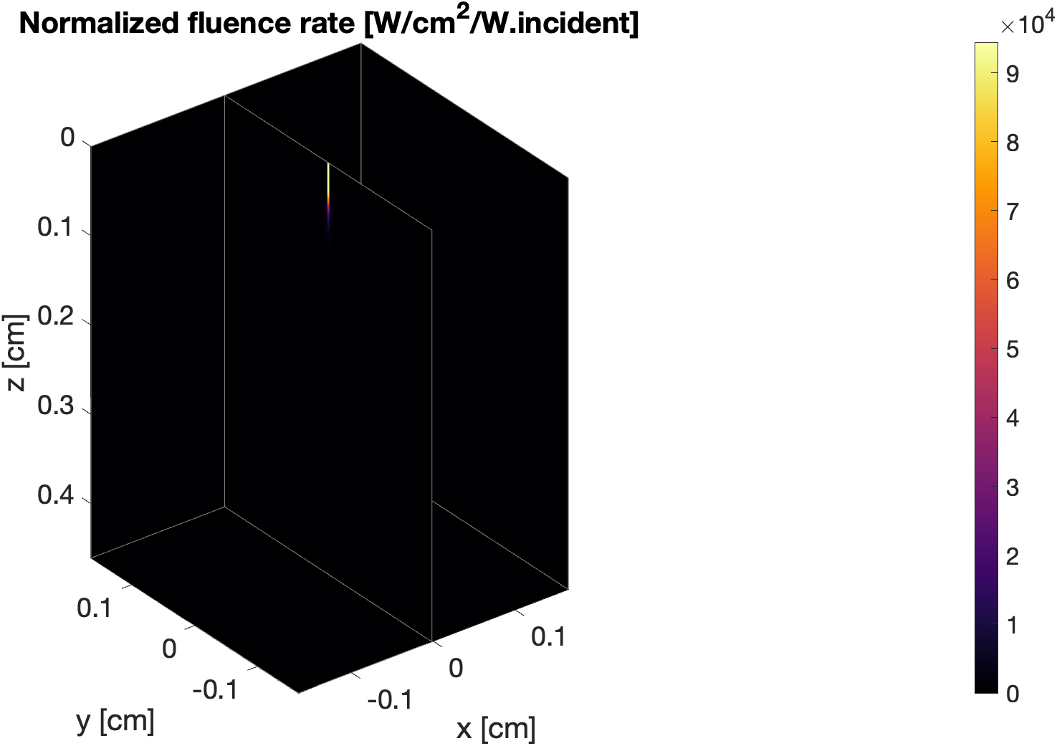

**Green LED Simulation**

* Power: 17.2 mW
* Wavelength: 537 nm
* MC Simulation Parameters
  + Distance between sensor and LED = 4.72 mm = 0.472 cm
  + # of photons simulated =9.15x105 photons
  + Simulation duration = 0.1 minutes
  + Photon simulation rate = 9.14x106 photons per minute
* MC Simulation Results
  + 30.5% of incident light was absorbed within the cuboid
  + 69.5% of incident light hits the cuboid boundaries.
* Model geometry



* Reflectance fluence

